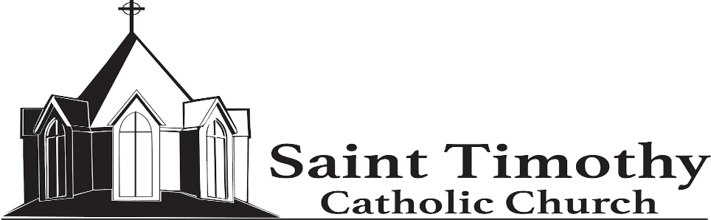
13807 Poplar Tree Road, Chantilly, VA 20151
(703)378-9143
ccd@sttimothyparish.org

Religious Education Registration 2024-25

Father’s Name: |  | Primary Phone:
Mother’s Name: |  | Emergency Contact Name:
Address: |  | Emergency Contact Phone:
City/Zip: | Email: | - Returning Family  - New Family

Student Name  Last, First, Middle | Male/ Female | Grade in Fall 2024 | Date of Birth | Date of Baptism | Church of Baptism | Has received First Communion?
Please note any allergies, medications, or special learning requirements:

Volunteers:
The success of our Religious Education Program depends on many volunteers. Please indicate by circling a position you can help with for any of the following:
Teacher Teacher’s Assistant Substitute Hall Monitor/Dismissal Aide

First Communion and Confirmation preparation is two-year process. The recommended period for First Communion is 1st and 2nd grade.
Confirmation preparation is typically 7th and 8th grade.
**Second grade students that are missing year one of First Communion preparation will receive their Sacrament after a two-year preparation period.**
Students in grades 3rd-12th that are off the recommended Sacramental timeline must enroll in the Missing Sacraments Program.

Class Time Options: please indicate your 1st and 2nd choice:
Kindergarten classes are ONLY offered at the 4:45pm time slot. (PreK classes are no longer offered).
Classes are once a week and begin the week of September 9th.
- Tuesday 4:45pm-6:00pm | - Wednesday 4:45pm-6:00pm
- Tuesday 4:45pm-6:00pm Kindergarten | - Wednesday 4:45pm-6:00pm Kindergarten
- Tuesday 7:00pm-8:15pm | - Wednesday 7:00pm-8:15pm
- Home Taught | - Missing Sacraments – Thursday 7-8:15pm
- SPRED – Special Religious Education – Bimonthly, Sundays 3-4:00pm

Registration Fee (NON-REFUNDABLE): | Sacramental Fees:
- 1 child, $100 | - $20 – First Communion
- 2 children $150 | - $50 – Confirmation
- 3 or more children, $200 | - $50 – Year 2 Missing Sacraments

*If tuition presents financial hardship, please contact the Office of Religious Education.

Payment options: Check – make payable to St. Timothy CCD

Cash
Credit card – scan the QR code or visit the URL below
http://membership.faithdirect.net/givenow/VA13/32495
There is a late fee of $20 for registrations received after August 10th .
The last day of registration is August 29th

****Registrations are not complete until baptismal & birth certificates
and registration fees have been submitted. ***

To be completed by Religious Education Office:

Date Received: | Payment Type & Amount: |  | - Check | - Cash | - Faith Direct
- Registration Fee | - Baptismal Certificate | - Birth Certificate |  | - PDS Entered

